Dear Parents/Carers,


A very warm welcome to the start of another exciting and busy year in Year 3. The children have settled well into their new classrooms and have already begun working on the interesting topics we have planned for them this term.

The teachers working in Year 3 are:
3C Ms Caliskan
3M Ms Moses
3G Ms Georgiou

HLTA: Mrs Soteriou

Teaching assistants: Mrs Bocock, Mrs Fletcher, Ms McCarthy

Assistant Headteacher: Miss Begum

English
Children will be studying a range of narrative texts where we will be learning to write recounts. Children will be innovating their narratives in order to demonstrate the grammatical features they have learnt during the lessons. We will also develop our understanding of non-fiction texts and focus on writing non-chronological reports. In addition, we will be continuing to study poetry and look at rhyming poems. In Reading, we will be reading ‘The tunnel’, ‘The Boy Who Grew Dragons’ and ‘The Fossil Girl’. Please encourage your children to read regularly at home – ideally, they should read for at least 20 minutes every day.

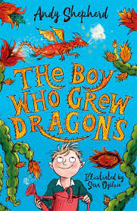
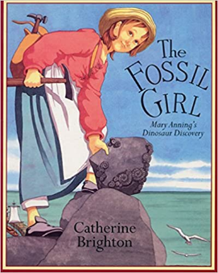
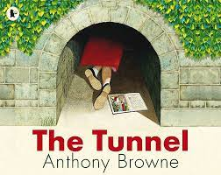

Maths
The children will develop their arithmetic skills, the application of the four operations, place value, fractions, money and Roman Numerals. There is a large emphasis on learning all of the times tables in Key Stage Two. The children should practise and learn the times tables off by heart. They will also be encouraged to develop their skills in problem solving, reasoning, giving explanations and applying their own ideas and strategies to solve number problems. Please continue to support your children in learning their times tables and encourage children to log on to TTRS. We will continue uploading weekly homework via My Maths.




Science
In Science, the children will be studying ‘Animals including Humans’. Children will build on their knowledge of the human body and revisit the importance of eating the right amounts of different types of food, but will extend this knowledge to understand that the food we eat provides us with the nutrition that our bodies require to remain healthy. They will learn about the range of nutrients that humans need to consume in the correct amounts and the role that these nutrients play in keeping our bodies healthy. They will also learn that humans and some other animals have skeletons and muscles for support, protection and movement. When working scientifically, children will ask and answer their own questions about the human body and diet through classifying, pattern-seeking investigations and by carrying out research using secondary sources. During the second half term, children will be learning about ‘Rocks and Soils’. Children will learn to classify different rocks.

RE
This term we will be learning about Hinduism and after half term we will be learning about Christianity.

Computing
Children will continue learning about E-safety. We will learn about networking and the World Wide Web (WWW).

Music
Music lessons are taught by a specialist teacher. To develop children’s understanding of rhythm and pitch, children will be creating and transferring clapping patterns to tuned instruments. They will also rap accurately and rhythmically.

History
In history, we will be learning about the ‘Stone Age’. Children will be developing their skills in chronology and will be looking at artefacts to explore the past.

Geography
In geography, children will be learning longitude and latitude.

Art
Children will be learning about creating their own early paintings inspired by The Stone Age.

Design and Technology
Children will be learning to design and make healthy shelf structures.

PE
Children will be participating in outdoor and adventurous activities. Our other will focus on outdoor Games which will be taught by Coach Matthew.

MFL
In French, the children will be learning greetings and farewells. They will learn how to ask “What is your name?” and say “My name is...” They will also say and numbers between 0 and 10 as well colours.

Homework
Maths homework will continue to be set online through MyMaths. Children must continue practising their times tables using Times Tables Rockstars as well as reading daily. We expect that all children complete their homework. If your child is having difficulty with the homework, they need to ask their class teacher for assistance.

Reading
Children are expected to read at home every day and then record what has been read in their Reading Diary, which will be checked weekly in school. Reading is key to accessing all areas of the curriculum and needs to be practised at home as much as possible.

Uniform and P.E
Thank you to all those parents/carers who have sent their children to school in full school uniform. A few reminders: footwear should be either plain black shoes or trainers and the only jewellery which children are allowed to wear are a small watch and stud earrings in pierced ears for safety reasons. Children in Year 4 will be doing P.E twice a week. All children are required to wear appropriate P.E kits – navy or black plain shorts or tracksuit bottoms and house coloured t-shirts. P.E kits should be worn to school on PE days.

3C: Mondays and Wednesdays
3M: Tuesdays and Wednesdays
3G: Mondays and Wednesdays

Attendance and Term Time Absence
Please ensure your child is at school on time every day. Gates open at 8.45am and the register is taken promptly at 8.55am. It is essential to children’s learning that they are present at the beginning of every lesson.

Please note: The Government expects children to maintain an attendance rate of 96% each year. It is not acceptable to request lengthy periods of absence due to the impact this will have on your child’s education. A request for Permission for Absence in Exceptional Circumstances should be made Ms Ahmet prior to making any travel arrangements. Each request will be reviewed on an individual basis. You will be expected to provide evidence to support the reason for your request for absence from school.

IMPORTANT DATES

Parents’ Evenings at school:
Wednesday 18th October 3.30-5.30
Thursday 19th October 3.30-5.30

School Closures:
- Last day of the half term Friday 20th October (school finishes 3.20 normal time)
- Half Term: 23rd – 27th October
- INSET day: Monday 30th October – INSET Day -SCHOOL CLOSED
- Last Day of Autumn Term: Wednesday 20th December - School ends at 2pm

Any questions or queries about anything mentioned in this letter please make an appointment with your child’s teacher.

Thank you for your continued support.

