Dear Parents/Carers,

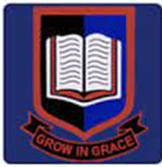
A very warm welcome to the start of another exciting and busy year in Year 4. The children have settled well into their new classrooms and have already begun working on the interesting topics we have planned for them this term.

The teachers working in Year 4 are:
4JR Mr Robinson
4LR Miss Rebecca
4B Miss Brown

HLTA: Mrs Soteriou

Teaching assistants: Mrs Asskoumi, Mrs Fletcher, Ms Akarsu

Assistant Headteacher: Miss Begum

English
Children will be learning about Ancient Greek Myths and Legends. We will be writing recounts based on ‘Arachne and Athena’, including diary entries. Children will develop their narrative skills and continue developing their stamina in writing. We will also work on instruction texts and children will be learning to write instructions for brushing their teeth which links. In the second half term, children will be learning to write adventure stories and will learn how to write non-chronological reports based on volcanoes and earthquakes. For our poetry units, we will be writing limericks.

In reading, we will continue improving our skills in: retrieval, inference, questioning and evaluating skills. Children will continue finding evidence from the text. Our class books for this term include: ‘I am Arachne’ by Elizabeth Spires and ‘The Firework Maker’s Daughter’ by Philip Pullman. Please encourage your children to read regularly at home – ideally, they should read for at least 20 minutes every day.

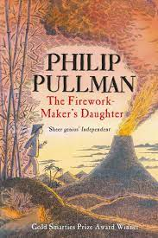
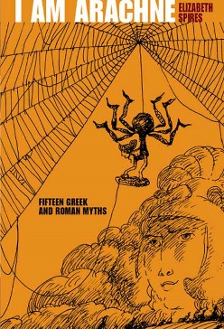

Maths
The children will develop their arithmetic skills, the application of the four operations, place value, fractions, money and Roman Numerals. There is a large emphasis on learning all of the times tables in Key Stage Two. The children should practise and learn the times tables off by heart. They will also be encouraged to develop their skills in problem solving, reasoning, giving explanations and applying their own ideas and strategies to solve number problems. Please continue to support your children in learning their times tables and encourage children to log on to TTRS. We will continue uploading weekly homework via My Maths.




Science
In Science, the children will be studying ‘Animals including Humans’. Children will build on knowledge of the human body and learn about the human digestive system. They will learn in more detail about the roles of the different types of teeth in breaking food down and how to care for their teeth. When working scientifically, children will ask and answer questions about teeth, digestion and food chains by carrying out research using secondary sources. They will group and classify teeth by their functions.

RE
This term we will be learning about Judaism and in particular - how family life and festivals show what matters to Jewish people.

Computing
Children will continue learning about E-safety. Children will continue learning about E-safety. We will learn about networking, the World Wide Web (WWW) and security.

Music
Music lessons are taught by a specialist teacher and the children will learn. This term, children will learn to play the guitar, leading to a performance at the end of the term.

History
In history, we will be learning about the Ancient Greeks. We will be studying Greek life and achievements and their influence on the western world.

Geography
In our geography unit, we will be looking at volcanoes. Children will be learning about how volcanoes affect a place.

Art
Children will be taking inspiration from Ancient Greek Art to sculpt pottery using clay.

Design and Technology
Children will be applying their knowledge on nutrition and varied diets to make sandwich snacks.

PE
Children will be participating in outdoor and adventurous activities. Our other will focus on outdoor Games which will be taught by Coach Matthew.

MFL
In French, the children will be learning to ask and answer several questions about themselves. They will say and write nouns for classroom items.

Homework
Maths homework will continue to be set online through MyMaths. Children must continue practising their times tables using Times Tables Rockstars as well as reading daily. We expect that all children complete their homework. If your child is having difficulty with the homework, they need to ask their class teacher for assistance.

Reading
Children are expected to read at home every day and then record what has been read in their Reading Diary, which will be checked weekly in school. Reading is key to accessing all areas of the curriculum and needs to be practised at home as much as possible.

Uniform and P.E
Thank you to all those parents/carers who have sent their children to school in full school uniform. A few reminders: footwear should be either plain black shoes and trainers for PE. The only jewellery which children are allowed to wear is a small watch and stud earrings in pierced ears for safety reasons. Children in Year 4 will have P.E twice a week. All children are required to wear appropriate P.E kits. – navy or black plain shorts or tracksuit bottoms and house-coloured t-shirts. P.E kits should be worn to school on PE days.

4JR: Mondays and Tuesdays
4LR: Mondays and Wednesdays
4B: Wednesdays and Fridays

Attendance and Term Time Absence
Please ensure your child is at school on time every day. Gates open at 8.45am and register is taken promptly at 8.55am. It is essential to children’s learning that they are present at the beginning of every lesson.

Please note: The Government expects children to maintain an attendance rate of 96% each year. It is not acceptable to request lengthy periods of absence due to the impact this will have on your child’s education. A request for Permission for Absence in Exceptional Circumstances should be made Ms Ahmet prior to making any travel arrangements. Each request will be reviewed on an individual basis. You will be expected to provide evidence to support the reason for your request for absence from school.

IMPORTANT DATES

Parents’ Evenings at school:
Wednesday 18th October 3.30-5.30
Thursday 19th October 3.30-5.30

School Closures:
- Last day of the half term Friday 20th October (school finishes 3.20 normal time)
- Half Term: 23rd – 27th October
- INSET day: Monday 30th October – INSET Day -SCHOOL CLOSED
- Last Day of Autumn Term: Wednesday 20th December - School ends at 2pm

Any questions or queries about anything mentioned in this letter please make an appointment with your child’s teacher.

Thank you for your continued support.

